**Accessing OGC WMTS Web Services**

**in**

**ArcGIS Desktop and ArcGIS Online**

The OGC (Open Geospatial Consortium) is an international, not for profit organization that establishes and supports open standards for the geospatial community. These standards are made through a consensus process and are intended to improve sharing of geospatial data. A Web Mopping Tile Service (WMTS) is a type of service, designed to quickly and seamlessly display map images and photography.

     Below are instructions for GIS users on how to access WMTS resources, in ArcGIS Desktop or ArcGIS Online. To access the WMTS service, a properly formatted URL must be available. Below is an example of a properly formatted WMTS URL for use in ArcGIS Desktop or ArcGIS Online:

https://storms.ngs.noaa.gov/storms/tilesg/services/tileserver.php/wmts

In either environment, once the WMTS data source [URL] is instantiated as a data source, it can be accessed by many different applications. This process is described, below, for both ArcGIS Desktop and ArcGIS Online.

* **ArcGIS Desktop – ArcCatalog and ArcMap**
  + In ArcCatalog, create a new WMTS Service Connection
    - In the “GIS Servers" folder
    - Click, “Add WMTS Server” ➔
    - Copy the Server URL, from the NOAA email
    - Paste it into the URL Textbox
    - Click “Get Layers” to see:

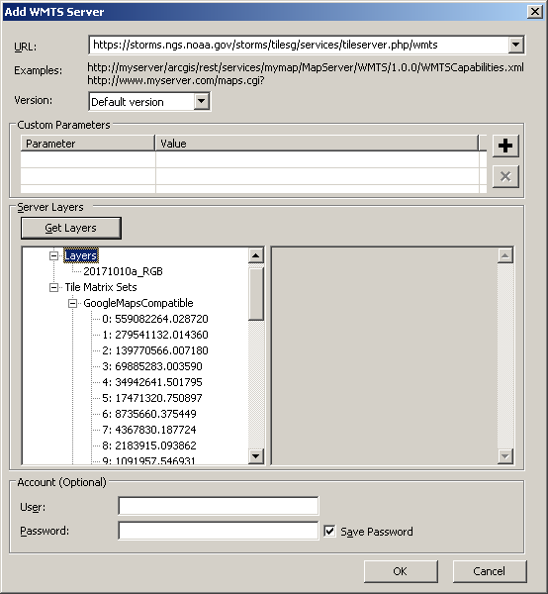

* + - Click “OK” to create the WMTS Server Connection
    - Rename the connection to clearly identify what it is.
  + This now provides access to the server and all of its services/content in all ArcGIS Desktop applications.
* **ArcGIS Online (AGO) – Create a “Content” source of add to a Map**  
  You can add as a source in your “Content Folders” or directly into a Map.  If you add it as a “Content Item,” you can use it anywhere in AGO.  If you add it into a Map, it will only exist in that map when you “Save” it.  I recommend the former and will outline that process, below.
  + Log-into AGO
  + Click on, “Content” at the top of the screen, to go to your “Content” page.  
      
    You should organize your content in folders with names related to what is in them.  Different people have different ways to organize their data.  You may keep all imagery sources in one folder.  Or, in this case, you may want to have a folder for NOAA content or perhaps a folder for content related to the storm, Nate.
  + Select the folder in which you wish to create the connection to the WMTS Server, by clicking on it or creating a new one.  
    - To create a new folder, click, “New” at the top of the Folder List
    - In the Dialog Box, enter a name for the new folder  
        
      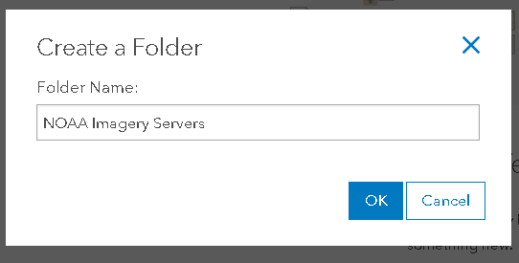
  + Click “OK” to create the folder.
  + When the Dialog Box closes, you will be in the empty, new folder.
* To add content to a folder:  
  + Click the “Add Item” dropdown, in the upper left, above he folder list
  + Select. “From the Web” to get the Dialog Box:  
      
    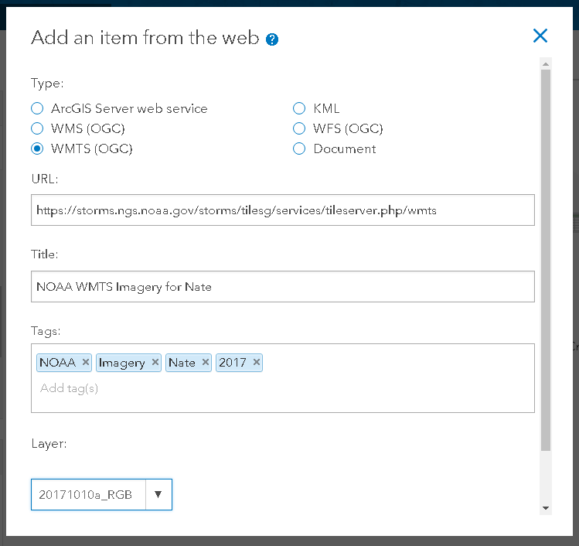  
    - Select the, “WMTS (OGC)” Radio Button.
    - Paste the URL, into the URL Textbox.
    - Enter a name I the Title Textbox.  This will appear in your Content List.
    - Enter “keywords” in the Tags Textbox.  Select key words and phrases that accurately depict the content so they can be effectively discovered by searches.
    - The “Layer:” dropdown will automatically populate, from your URL.
    - Click the “Add Item” Button (You may need to scroll down to see it).
  + The new Content Item’s “Details” web page will appear.  
      
    On this page, you should complete documenting your new Content Item by filling in:
    - Description – Describe what this is, what it contains, and other useful background information.
    - Access and Use Constraints – If there are none, enter, “None.”
    - You can also modify the graphic thumbnail associated with the Details page/item.
    - Modify Tags (keywords).
    - There are many settings to explore on this page.
  + The **FINAL Step** is to “Share” the content item.  By default, you are the only one with access to the Content Item.  To share it, click the “Share” Button on the left side of the “Overview” Tab on the Details Page.  You will get a Dialog Box with a list of Groups or other entities with which you can share.  This list will differ, depending on the role your account is assigned.

**Final Notes**

These processes are documented in both the ArcGIS Desktop and ArcGIS Online Help systems. For more detailed information, please refer to those resources. The instructions provided, above, are intended as a “quick start,” shortcut for simple reference. The accuracy and effectiveness of the above outlined processes were developed in September, 2017, using ArcGIS Desktop Version 10.4.1 and the version of ArcGIS Online that was in production at that time. They can be affected by changes in the capabilities and configuration of the underlying systems, which are subject to change, without notice. If problems are encountered, refer to the Help system for your software. Otherwise feel free to contact me. Using the contact

Jim Mitchell

[jim.mitchell@la.gov](mailto:jim.mitchell@la.gov)

225-379-1881

|  |  |
| --- | --- |
| **James E. Mitchell, Ph. D.**  **State of Louisiana**  **Office of Technology Services**  **Louisiana Dept. of Transportation & Development Computer Center 1201 Capitol Access Rd Baton Rouge, LA 70802-4438** | **Voice: 225/379-1881 FAX:  225/379-1850**  **Email:** [**Jim.Mitchell@la.gov**](mailto:Jim.Mitchell@la.gov) **WWW:** [**http://www.dotd.la.gov**](http://www.dotd.la.gov/)  [**http://gis.dotd.la.gov**](http://gis.dotd.la.gov/)  [**http://LADOTD.maps.arcgis.com**](http://ladotd.maps.arcgis.com/) |

