0317_Easier.jpg
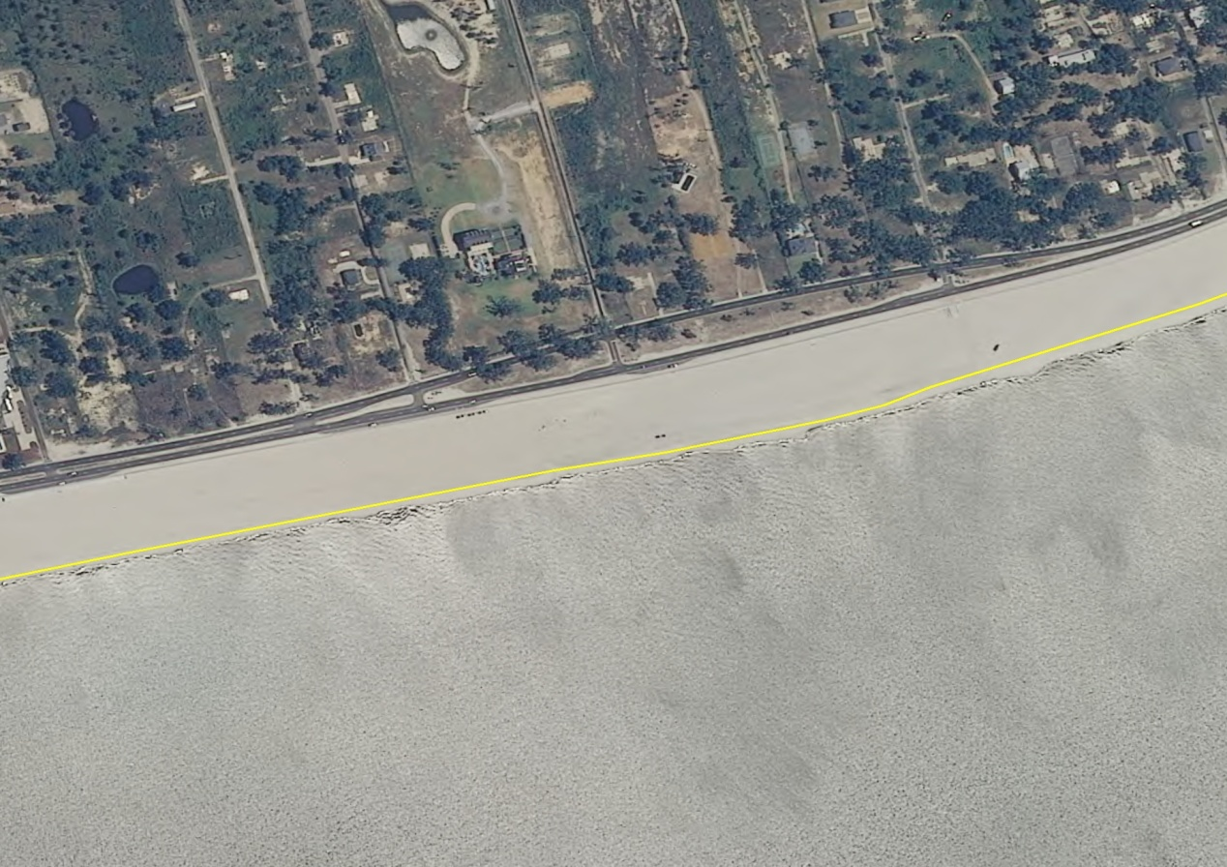
An example of easy to compile coastline. Smooth, sandy beach.
0318_Medium.jpg
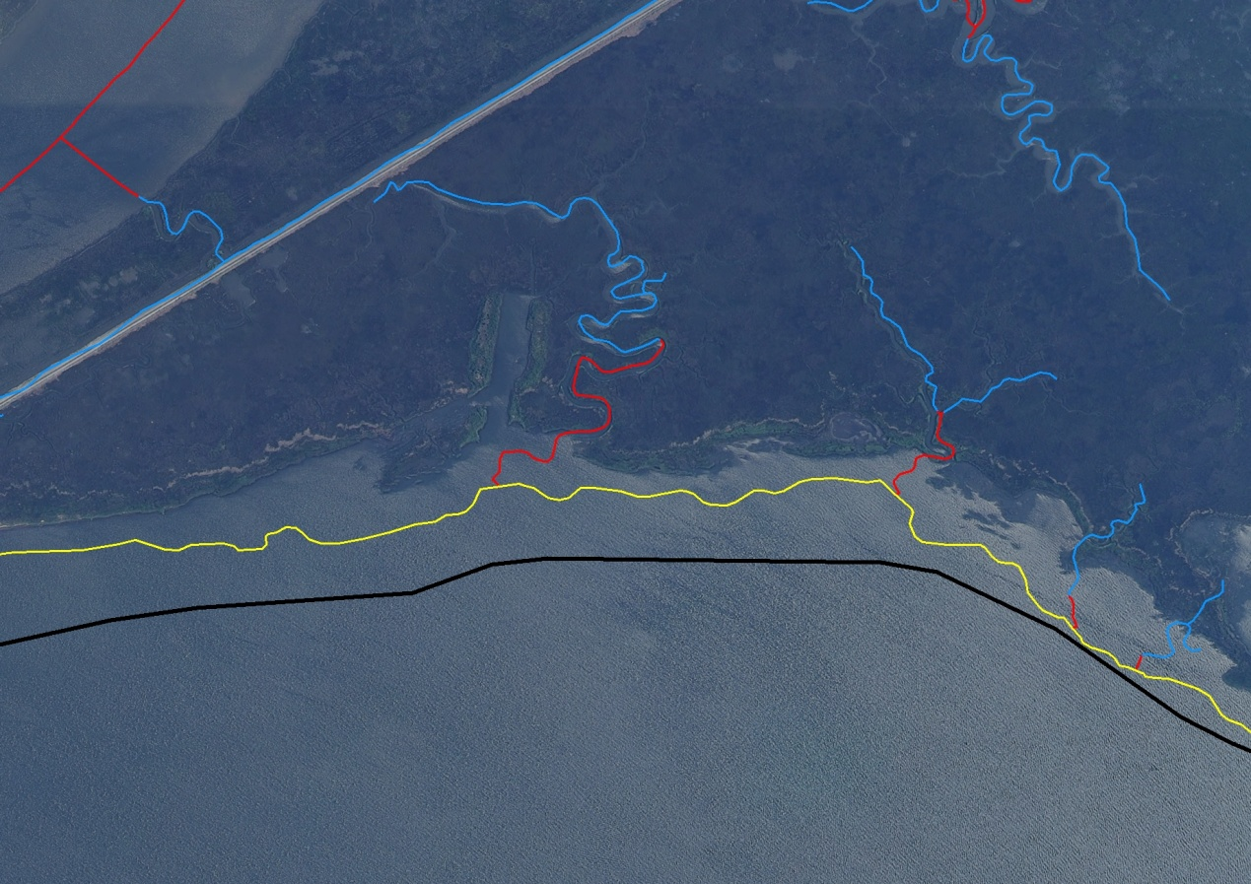
An example of a medium coastline. Forested SwampMarsh with coarse coastline.
0809_difficult.jpg
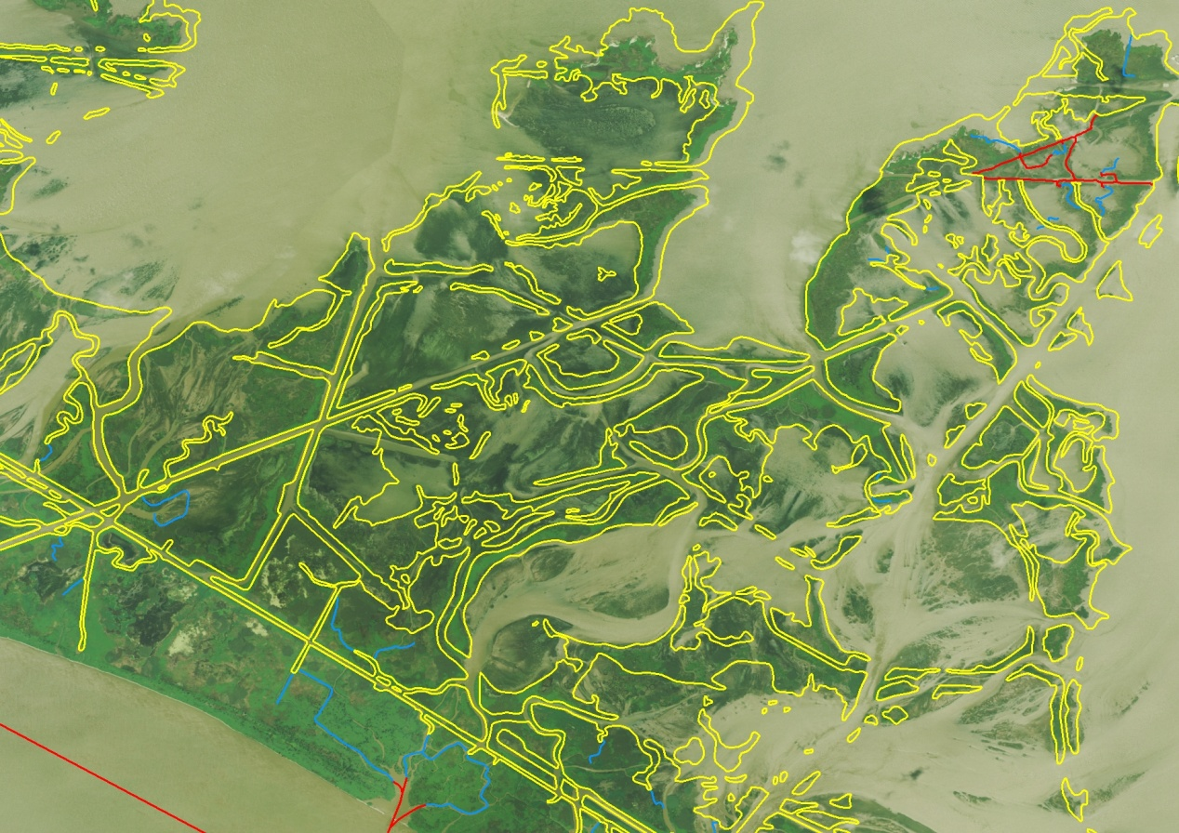
An example of a difficult coastline. SwampMarsh area with loads of detail, that will change next year.
0317_ActualCoast.jpg
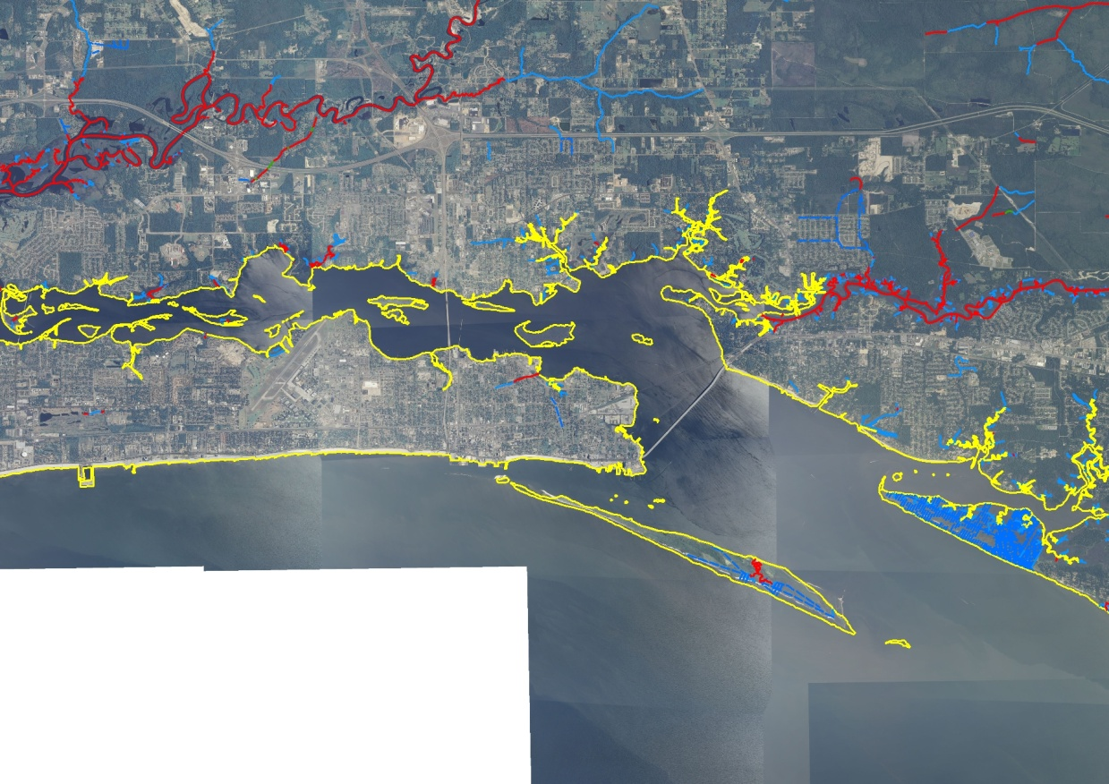
An example where the actual coastline was compiled, Notice the amount of work to collect the coastline interior to the bay.
0809_PsuedoCoastline.jpg
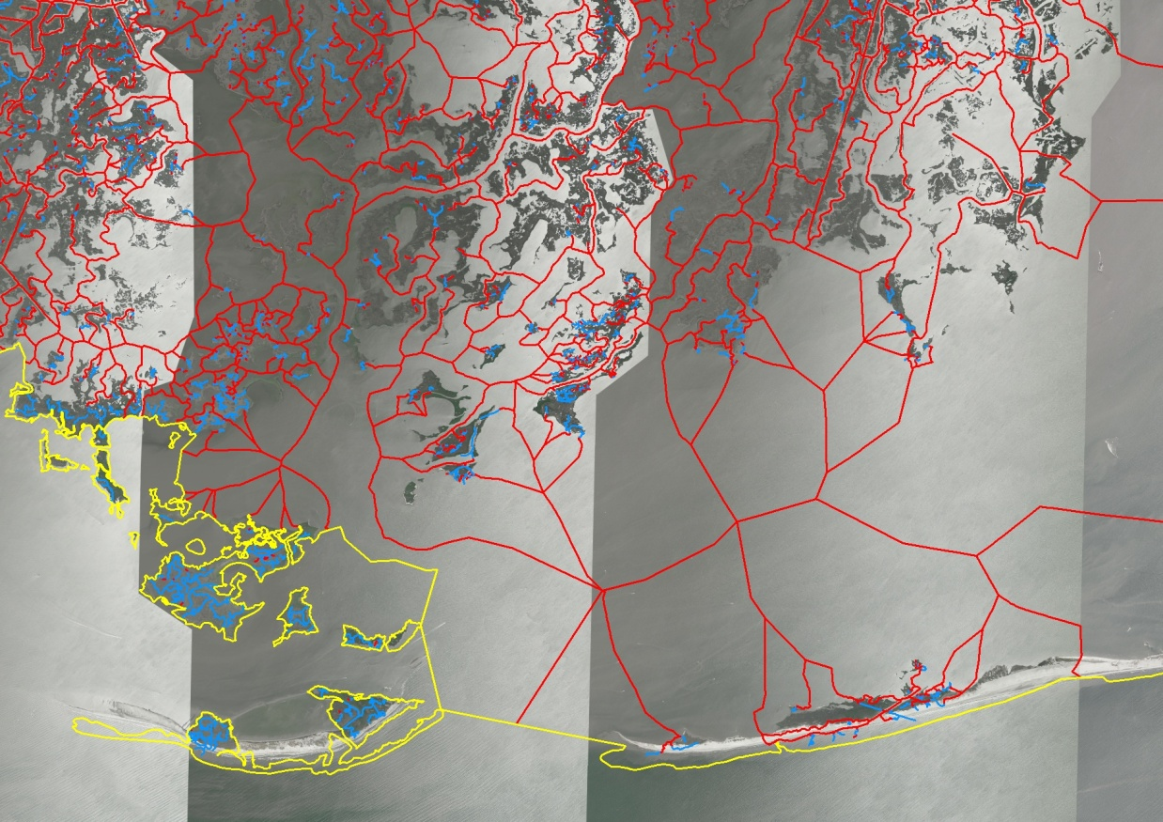
An example where a random vector representing the coastline was compiled from Bariier Island to Barrier Island. Eliminates compiling the detail of the islands to the north of the coastline
0317_BarrierIslands.jpg
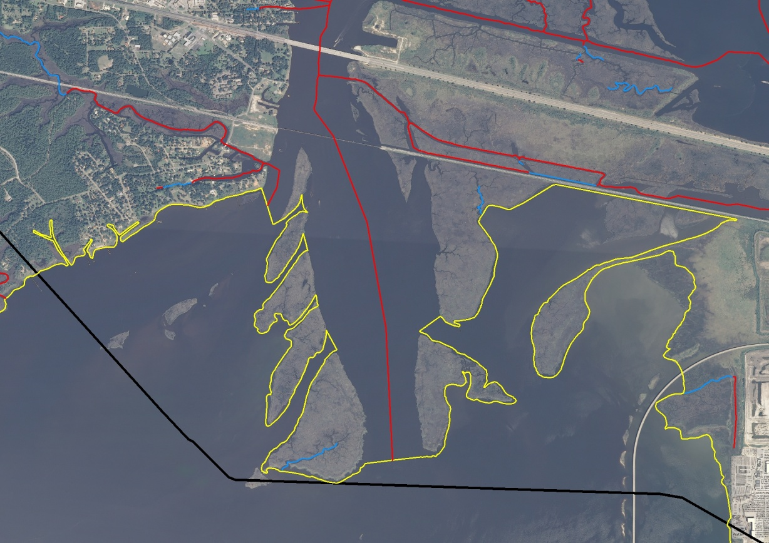
An example where compiling a psuedo coastline eliminates compiling up the large river.
0808_OffshoreIslands.jpg
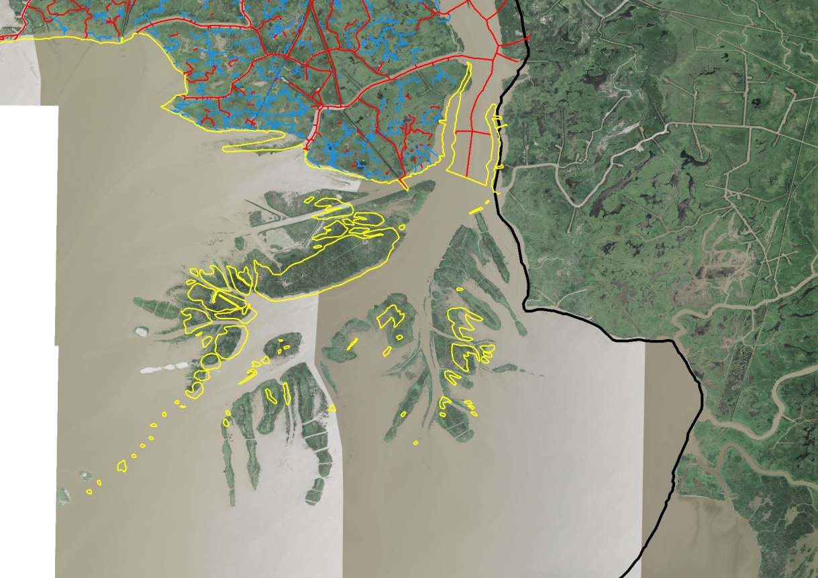
An example of many polygons offshore that change constantly.
0809_OffshoreIslands.jpg
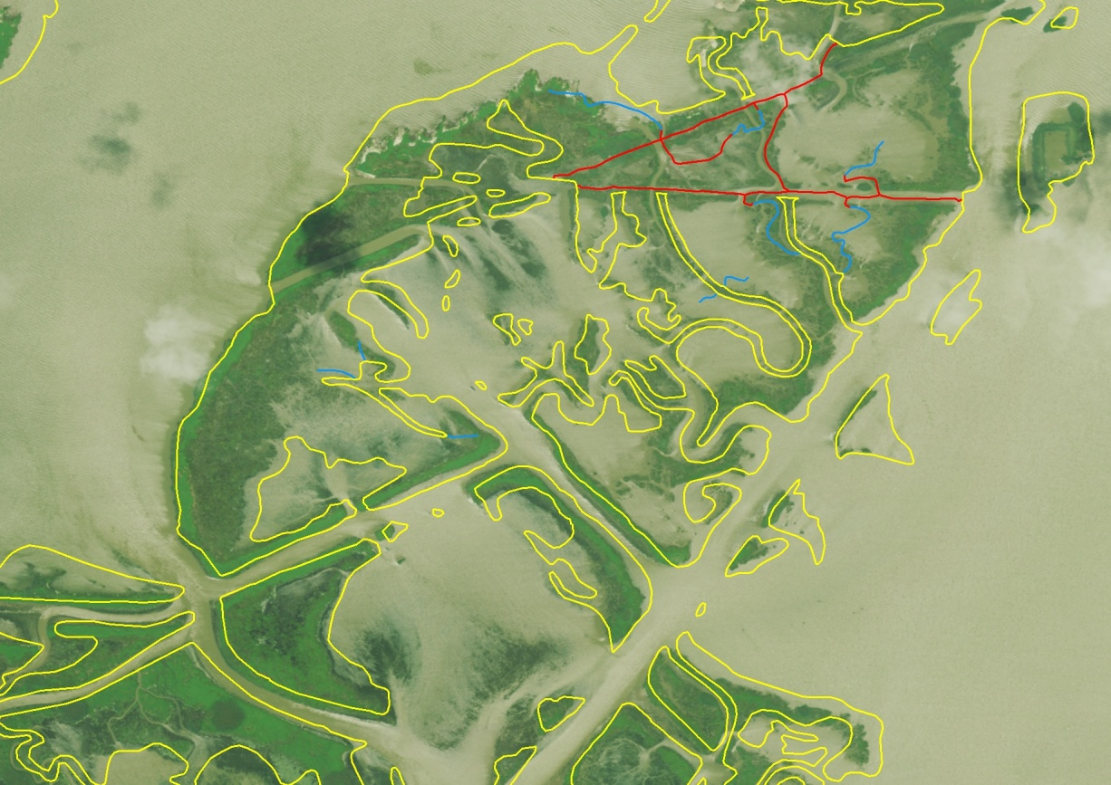
Another example of offshore islands that change shape often.

